🧠 🟢 LEVEL 1 — Basic SQL (Foundation)
🔹 1. Total Transactions
SELECT COUNT(*) AS total_transactions
FROM Transactions;
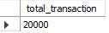
🔹 2. Total Transaction Amount
select round(sum(amount),2) transaction_amunt
from transaction;
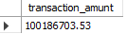
🔹 3. Transactions by Status
SELECT status, ROUND(SUM(amount), 2) transaction_amunt
FROM transaction
GROUP BY status;
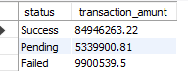
🔹 4. Customers by City
select city, count(customer_id) total_customer
from customer
group by city;
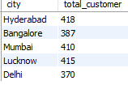
🟡 LEVEL 2 — Joins + Business Insights
🔹 5. Total Transaction per Customer
SELECT c.Customer_ID, SUM(t.Amount) AS total_spent
FROM Customers c
JOIN Transactions t ON c.Customer_ID = t.Customer_ID
GROUP BY c.Customer_ID;
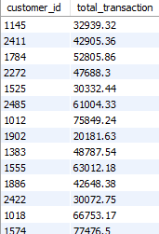

🔹 6. Average Transaction Amount by Payment Method
SELECT Method, AVG(Amount) AS avg_amount
FROM Transactions
GROUP BY Method;
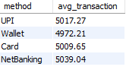

🔹 7. Account Balance by City
SELECT c.City, round(AVG(a.Balance),2) AS avg_balance
FROM Customers c
JOIN Accounts a ON c.Customer_ID = a.Customer_ID
GROUP BY c.City;
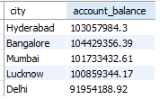

🔵 LEVEL 3 — Advanced SQL (Real Analytics)
🔹 8. Fraud Rate by Payment Method
SELECT
Method,
COUNT(CASE WHEN Fraud_Flag = 1 THEN 1 END) * 100.0 / COUNT(*) AS fraud_rate
FROM Transactions
GROUP BY Method;
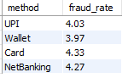

🔹 9. Top 10 High-Value Customers
SELECT Customer_ID, SUM(Amount) AS total_spent
FROM Transactions
GROUP BY Customer_ID
ORDER BY total_spent DESC
LIMIT 10;
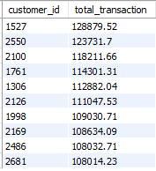

🔹 10. Customers with Loans + High Transactions
select t.customer_ id,round(sum(l.loan_amount),2) total_loan, round(sum(t.amount),2) total_amountfrom transaction t join loan l on
t.Customer_ID=l.customer_id
group by t.customer_id
order by total_loan ,total_amount desc;
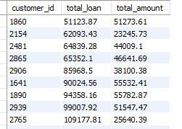

🔴 LEVEL 4 — Expert SQL (Industry-Level)
🔹 11. Fraud Rate Among Loan Defaulters
SELECT
l.Loan_Status,
COUNT(CASE WHEN t.Fraud_Flag = 1 THEN 1 END) * 100.0 / COUNT(*) AS fraud_rate
FROM Loans l
JOIN Transactions t ON l.Customer_ID = t.Customer_ID
WHERE l.Loan_Status = 'Default'
GROUP BY l.Loan_Status;
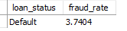

🔹 12. Monthly Transaction Trend
select monthname(date) months,round(sum(amount),2) total_amount
from transaction
group by months;
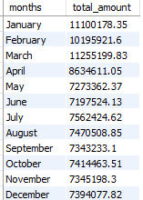
🔹 13. Detect Suspicious Transactions (High Amount + Fraud)
SELECT *
FROM Transactions
WHERE Amount > 8000 AND Fraud_Flag = 1;
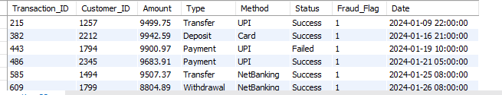

🔹 14. Customers with High Balance but Low Activity
SELECT c.Customer_ID, a.Balance, COUNT(t.Transaction_ID) AS txn_count
FROM Customers c
JOIN Accounts a ON c.Customer_ID = a.Customer_ID
LEFT JOIN Transactions t ON c.Customer_ID = t.Customer_ID
GROUP BY c.Customer_ID, a.Balance
HAVING a.Balance > 300000 AND txn_count < 5;
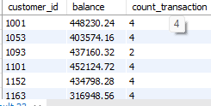

⚫ LEVEL 5 — Window Functions (🔥 Must for Interviews)
🔹 15. Rank Customers by Spending
SELECT
Customer_ID,
SUM(Amount) AS total_spent,
RANK() OVER (ORDER BY SUM(Amount) DESC) AS rank_position
FROM Transactions
GROUP BY Customer_ID;
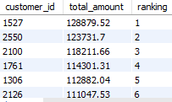

🔹 16. Running Total of Transactions
SELECT
Customer_ID,
Date,
Amount,
SUM(Amount) OVER (PARTITION BY Customer_ID ORDER BY Date) AS running_total
FROM Transactions;
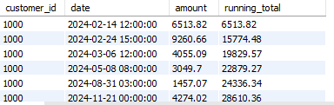

🧠 💼 CASE STUDY: Fintech Risk & Customer Intelligence
🎯 Business Problem
A fintech company wants to:
- Identify high-risk customers
- Detect fraud patterns
- Segment customers based on behavior
- Improve transaction success rate

📊 Tables You Will Use
- Customers
- Transactions
- Accounts
- Loans

🔴 TASK 1: Identify High-Risk Customers
📌 Definition:
A customer is high risk if:
- Fraud transactions ≥ 2
- OR Loan_Status = 'Default'
✅ SQL Solution:
SELECT
t.Customer_ID,
l.Loan_Status,
COUNT(CASE WHEN t.Fraud_Flag = 1 THEN 1 END) AS fraud_count
FROM Transaction t
LEFT JOIN Loan l
ON t.Customer_ID = l.Customer_ID
GROUP BY t.Customer_ID, l.Loan_Status
HAVING fraud_count >= 2
AND l.Loan_Status = 'Default';
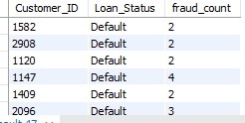

2nd way with percentage
SELECT
t.Customer_ID,
l.Loan_Status,
COUNT(*) AS total_txn,
COUNT(CASE WHEN t.Fraud_Flag = 1 THEN 1 END) AS fraud_count,
concat(round(COUNT(CASE WHEN t.Fraud_Flag = 1 THEN 1 END) * 100.0 / COUNT(*),2),"%") AS fraud_rate
FROM Transaction t
LEFT JOIN Loan l
ON t.Customer_ID = l.Customer_ID
GROUP BY t.Customer_ID, l.Loan_Status
HAVING fraud_count >= 2
AND l.Loan_Status = 'Default';
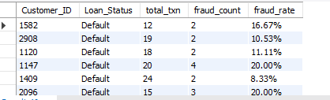
🟠 TASK 2: Fraud Pattern Analysis
Q1: Which City Has Highest Fraud Rate?
select c.city,
count(case when t.fraud_flag=1 then 1 end) fraud_count,
concat(round(count(case when t.fraud_flag=1 then 1 end)*100/count(Fraud_Flag),2),"%") fraud_rate
from customer c join transaction t on
c.Customer_ID=t.Customer_ID
group by c.city
order by fraud_rate desc;
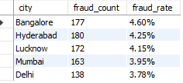
Q2: Fraud by Payment Method
select method,
count(case when fraud_flag=1 then 1 end) fraud_count,
concat(round(count(case when fraud_flag=1 then 1 end)*100/count(Fraud_Flag),2),"%") fraud_rate
from transaction
group by method
order by fraud_rate desc;
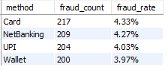

🔵 TASK 3: Customer Segmentation
📌 Segments:
- High Value → Total > 100000
- Medium → 50000–100000
- Low → < 50000
✅ SQL:
SELECT
Customer_ID,
SUM(Amount) AS total_spent,
CASE
WHEN SUM(Amount) > 100000 THEN 'High Value'
WHEN SUM(Amount) BETWEEN 50000 AND 100000 THEN 'Medium Value'
ELSE 'Low Value'
END AS segment
FROM Transactions
GROUP BY Customer_ID;
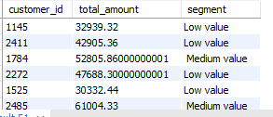

🟣 TASK 4: Detect Suspicious Behavior
📌 Condition:
- High transaction (>8000)
- Fraud = 1
SELECT *
FROM Transactions
WHERE Amount > 8000
AND Fraud_Flag = 1;
👉 You can extend this using time logic (advanced).
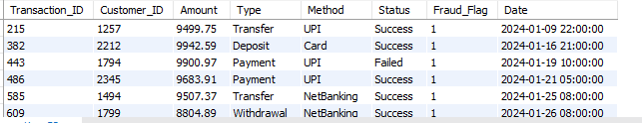

⚫ TASK 5: Time-Based Fraud Detection
Peak Fraud Hour
SELECT
HOUR(Date) AS hour,
COUNT(*) AS fraud_count
FROM Transactions
WHERE Fraud_Flag = 1
GROUP BY hour
ORDER BY fraud_count DESC;
2nd way
select hour(date) hour, count(case when Fraud_Flag=1 then 1 end) fraud_count
from transaction
group by hour
order by fraud_count desc;
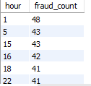

🟤 TASK 6: Customer 360 Analysis
📌 Combine:
- Transactions
- Account Balance
- Loan Status
select l.loan_status,round(sum(t.amount),2) total_trx_amount,round(sum(a.balance),2) account_balance
from transaction t join accounts a on
t.Customer_ID=a.Customer_ID
join loan l on
t.Customer_ID=l.Customer_ID
group by l.loan_status;
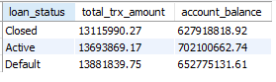

2nd way
SELECT
c.Customer_ID,
SUM(t.Amount) AS total_spent,
a.Balance,
MAX(l.Loan_Status) AS loan_status
FROM Customers c
LEFT JOIN Transactions t ON c.Customer_ID = t.Customer_ID
LEFT JOIN Accounts a ON c.Customer_ID = a.Customer_ID
LEFT JOIN Loans l ON c.Customer_ID = l.Customer_ID
GROUP BY c.Customer_ID, a.Balance;
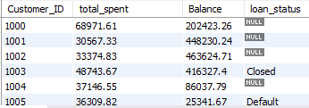

🔥 TASK 7: Advanced Window Function Case
Rank Customers by Spending
SELECT
Customer_ID,
SUM(Amount) AS total_spent,
DENSE_RANK() OVER (ORDER BY SUM(Amount) DESC) AS rank_position
FROM Transactions
GROUP BY Customer_ID;
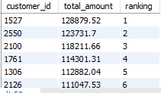

🧩 TASK 8: Detect Inactive High-Value Customers
📌 Logic:
- High balance (>300K)
- Low transactions (<5)
SELECT
c.Customer_ID,
a.Balance,
COUNT(t.Transaction_ID) AS txn_count
FROM Customers c
JOIN Accounts a ON c.Customer_ID = a.Customer_ID
LEFT JOIN Transactions t ON c.Customer_ID = t.Customer_ID
GROUP BY c.Customer_ID, a.Balance
HAVING a.Balance > 300000 AND txn_count < 5;
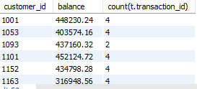

📈 TASK 9: Monthly Growth Analysis
SELECT
DATE_FORMAT(Date, '%Y-%m') AS month,
SUM(Amount) AS total_revenue
FROM Transactions
GROUP BY month
ORDER BY month;
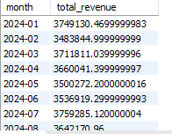
2nd way
select monthname(date) monthname,year(date) yearname,round(sum(amount),2) total_amount
from transaction
group by monthname, yearname;
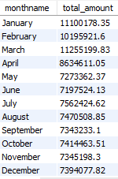

🎯 FINAL BUSINESS INSIGHTS (What You Should Conclude)
After running queries, you should answer:
- Which city is risky?
- Which payment method has highest fraud?
- Who are top customers?
- Who are high-risk users?
- When does fraud happen most?

